Lineups from Research papers:

Domain constraint: x ∈ [0,20]
Range constraint: y ∈ [10,100]
N=50 points randomly assigned throughout the domain.

We mapped the randomly generated x values to a corresponding y value based on an exponential model with predetermined parameter values and multiplicative random errors.

These constraints assure that participants who select the target panel are doing so because of their visual perception differentiating between curvature or growth rate rather than different starting or ending values.

Three-parameter exponential model with multiplicative errors:

$$y_{i}=α e^{βx_{i}+ ϵ_{i}}+ θ with ϵ_{i} \sim N(0, σ^{2})$$

Algorithm 1 Lineup Parameter Estimation

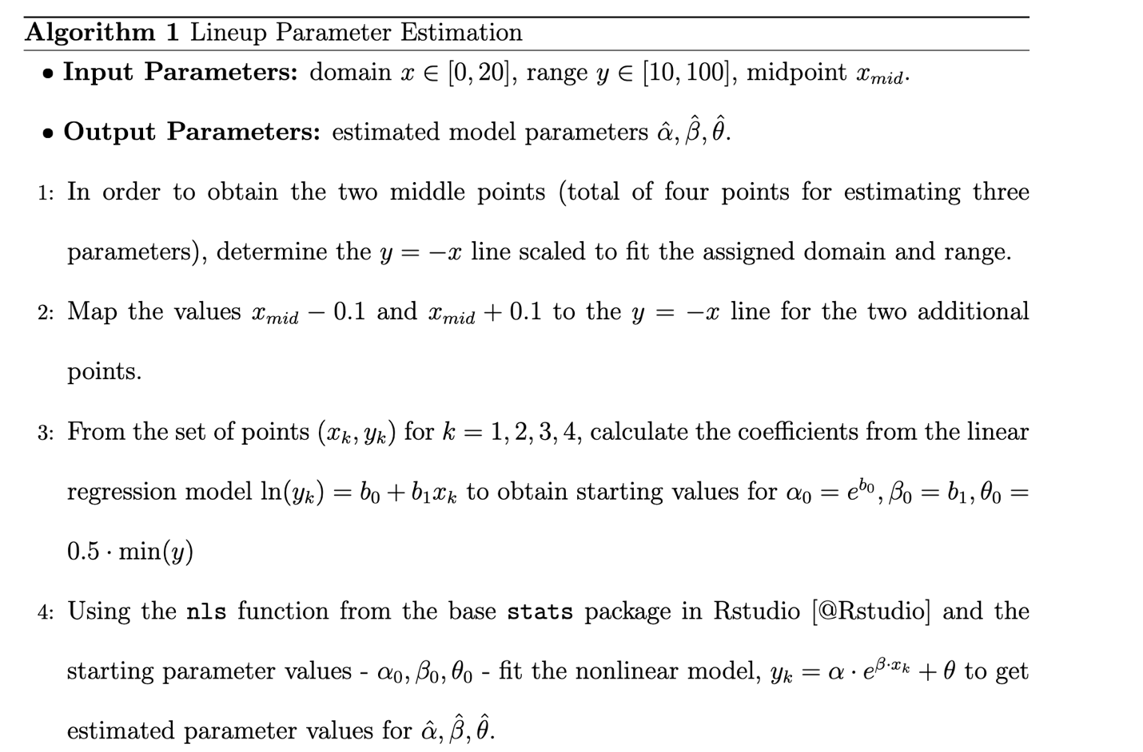

Algorithm 2 Lineup Exponential Data Simulation

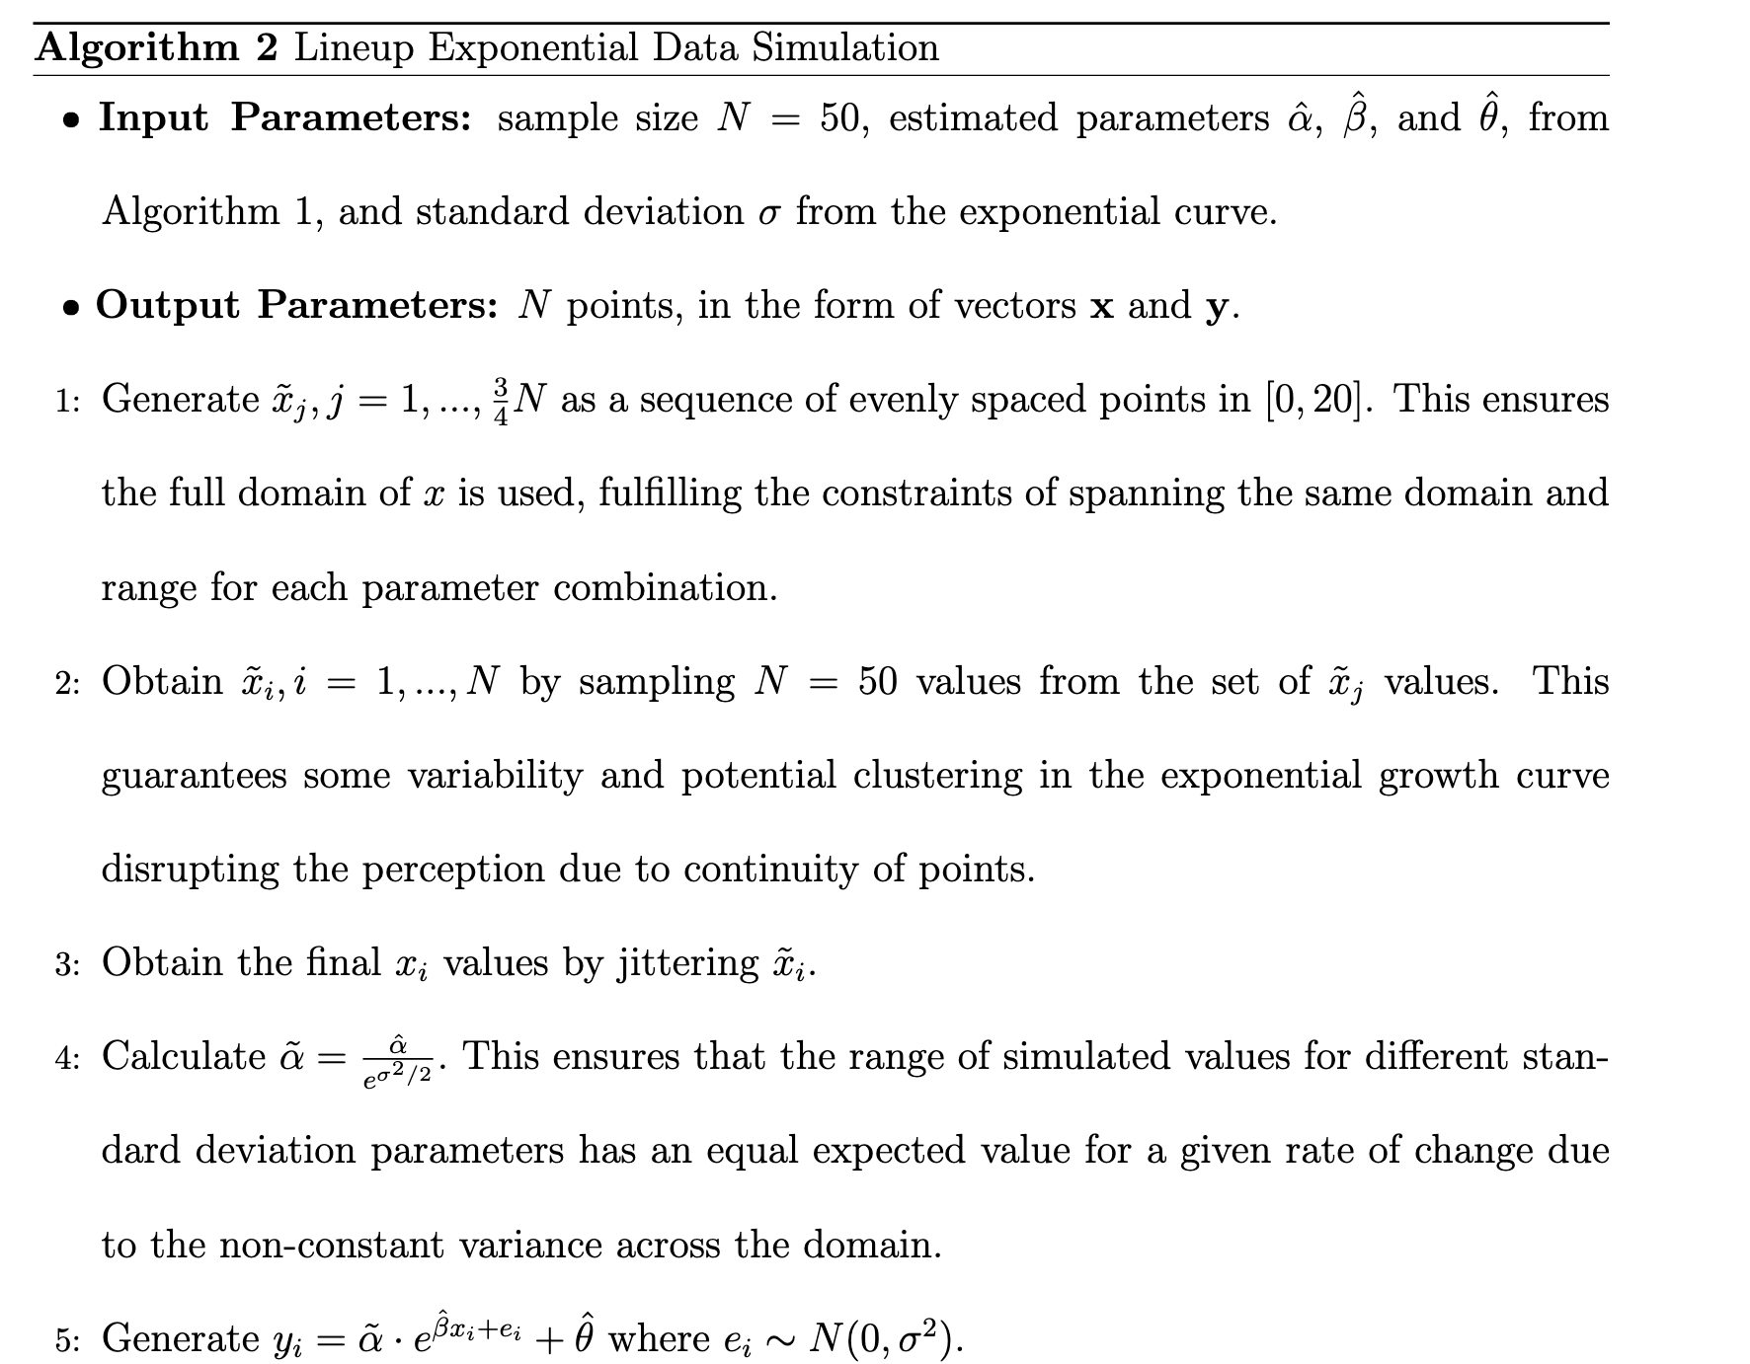

Design: within-subject factorial - every participant saw both scale conditions and all curvature pairs.
Stimuli: 24 unique test lineups (+ 3 Rorschach sets); each participant viewed 13 of them.

